README

Following steps need to be configured in order to bring Employee portal up

* Check out project
* Run Config.bat

**Project: service-discovery:**

This project Use Neltflix Service registry to register and publish micro-services of project employee-service.

* Run mvnw.bat in project “service-discovery”

NetFlix Eureka registry Service:  
<http://localhost:8761/>

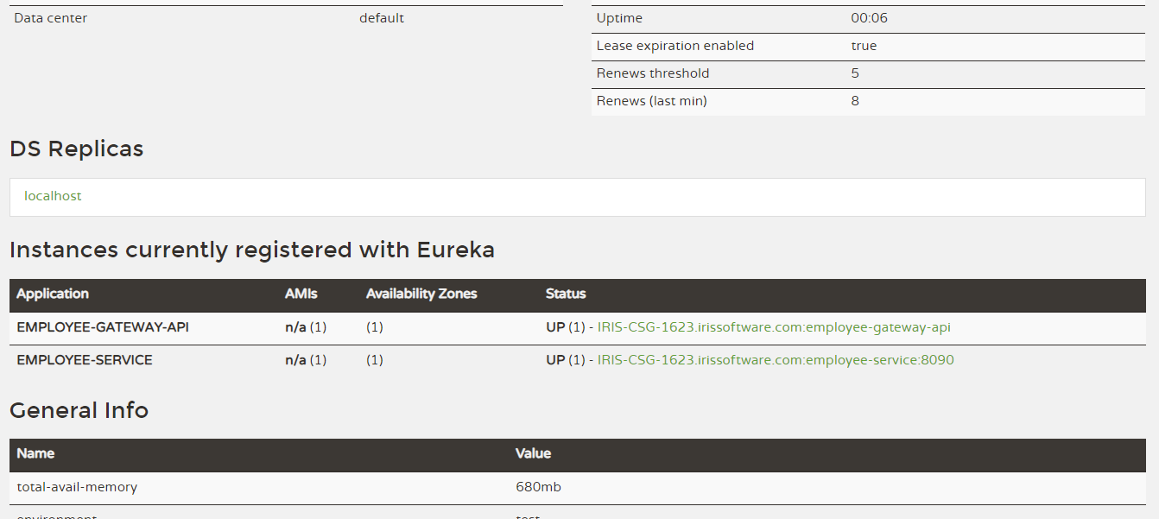

**Project: employee-service.**

This project provides RESTFull micro services and registered with Netflix to publish these services

* Run mvnw.bat in project “employee-service”

REST- Micro Services:  
<http://localhost:8090/employee-service/Employee/>

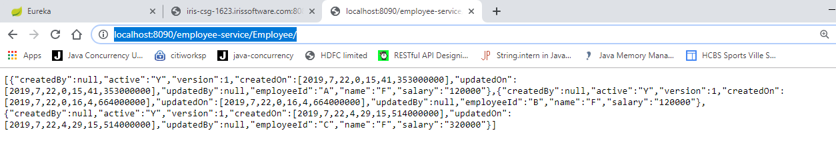

**Project: employee-gateway-api**

This application act as a API-Gateway for services exposed by employee-service.

* Run mvnw.bat in project “employee-gateway-api”  
  This project serve as a gateway for exposed micro-services. So, do not have any UIs for now.

Employee Portal (Employee Portal + API-Gateway:  
<http://iris-csg-1623.irissoftware.com:8080/employee-gateway/Employee/>

Project Employee-We.  
This project contains UIs for Employee Portal.  
For employee data, this application raised request to employee-gateway-api application.

employee-gateway-api application in response to, route request to related registered micro-services to serve data to Employee-web application



